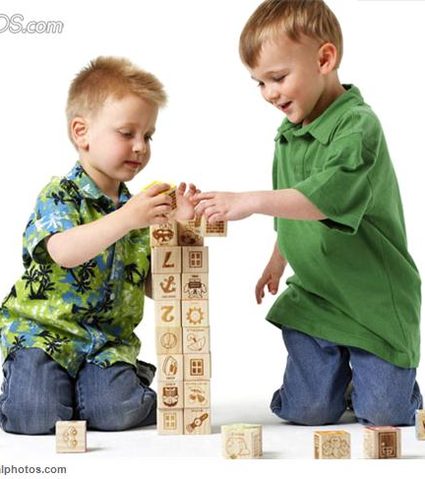

LESSON: Building a Conversation

OUTLINE

- We can build a conversation:
Step 1: Greet your friend
Step 2: Start the conversation – comment or question about a topic
Step 3: Listen – give your friend a chance to answer or comment
Step 4: Respond – answer or comment – stay on topic
Step 5: Keep it Going – ask another question, make a comment or wait for your friend to talk
- Practice, Practice, Practice
- Some things that can make the conversation “fall down”:
  - Poor eye contact
  - Not responding
  - Suddenly changing the topic
- “So, What Do You Think?”

- We can build a conversation – “Social Power” Point Card

MATERIALS NEEDED:
- Facilitator’s Guide
- Activity Sheet 1
- Activity Sheet 2
- Greeting sticks from Hellos and Goodbyes lesson (optional)
- “Social Power” Point Card or Magnet
- Homework Sheet –
- optional

