Social Skills –Parent Note

Your child just completed a social skills lesson. The topic was:
I Can Stress Less at School. Your knowledge of this lesson may help you to help your child generalize the skills to other environments.

What he/she learned:

- “Stress” is what you feel when you are worried or uncomfortable about something. It has physical and emotional effects.
- There are two different types of stress - good stress and bad stress. Good stress can help us get things done, prepare better, and practice more. Bad stress can make us upset, make us feel sick, make us mad, or make us frustrated.
- We can manage our stress by using the following strategies:
- There are 5 Ways to Handle Stress:
- Ask for help
- Stay calm
- Go easy on yourself
- Try to solve the problem
- Stay positive – this stress will pass
- Knowing how to manage stress allows us to take control!

Your child received a Lesson Summary magnet:
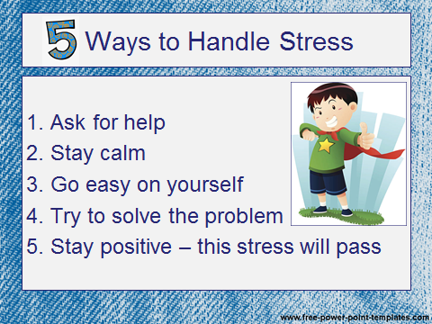

If you have a moment, email _____________________________ with any information that might help your child for the next lesson on ________________________. THANK YOU!!

