What’s Happening Today?

Let’s Talk About How to Stress Less at School

- What is stress?

- How does stress make you feel?

- There are two kinds of stress – good stress and bad stress. We can learn ways to manage our stress!

- There are 5 Ways to Handle Stress

- Ask for help
- Stay calm
- Go easy on yourself
- Try to solve the problem
- Stay positive – this stress will pass

- So what do you think??

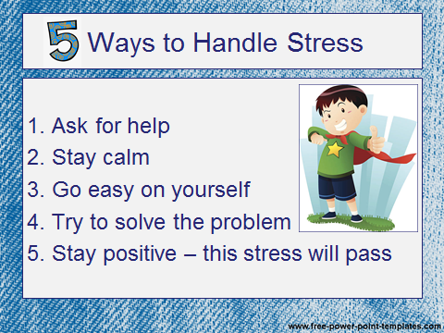
- Get your magnet!

