Social Skills –Parent Note

Your child just completed a social skills lesson. The topic was:
I Can Handle Waiting. Your knowledge of this lesson may help you to help your child generalize the skills to other environments.

What he/she learned:

- “Waiting” means to stay where we are, stop what we’re doing, delay what we want to do or get
- Waiting can be hard – there are many times we have to wait (i.e. wait in lines, wait to eat, wait for help, etc.)
- There are 4 TIPS TO HELP WITH WAITING:
- Stay still, quiet, and calm
- Think “It’s hard to wait but I can do it”
- Make a waiting plan
- Try your plan
- Students practiced the tips together and discussed things to do while waiting

Your child received a Lesson Summary magnet:
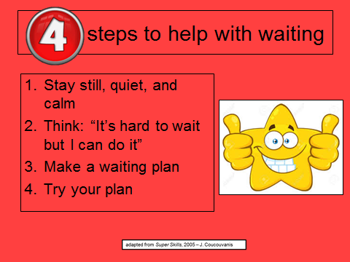

If you have a moment, email _____________________________ with any information that might help your child for the next lesson on ________________________. THANK YOU!!

