What’s Happening Today?

Let’s Talk About Tips to Help with Waiting

- What does waiting mean?

- Waiting can be hard but there are lots of times that we just have to wait

- What do YOU do to make waiting easier?

- There are 4 Tips to Help with Waiting

- Stay still, quiet, and calm
- Think “It’s hard to wait but I can do it”
- Make a waiting plan
- Try your plan

- Let’s practice!

- So what do you think??

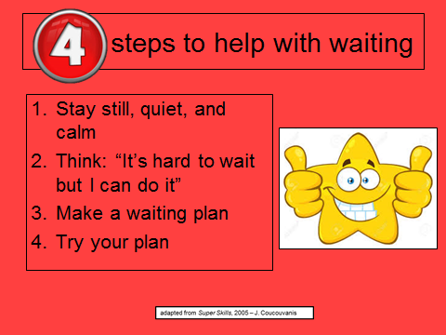
- Get your magnet!

