This week I might try:

To handle homework

I’ll try to remember that there are 3 tips for making homework a little easier.

I can keep track of what I’m learning on the chart below:

When I get homework this week, I can try to: | Day  1 | Day  2 | Day  3 | Day  4 | Day  5
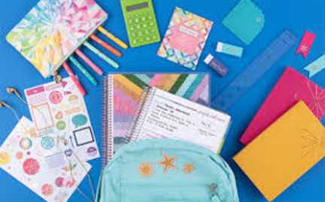
1. Get organized

2. Stay focused

3. Get it done!

