This week I might try:

To accept consequences

I’ll try to remember that there are ways to accept consequences that can help me take responsibility for my actions.

I can keep track of what I’m learning on the chart below:

If I get a consequence for a mistake I made, I can try to: | Day  1 | Day  2 | Day  3 | Day  4 | Day  5
1. Look at the person

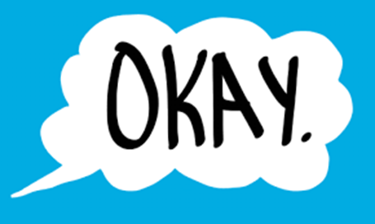
2. Say “okay”

3. Stay calm

4. Don’t argue

