Social Skills –Parent Note

Your child just completed a social skills lesson. The topic was:
I Can Show Compassion. Your knowledge of this lesson may help you to help your child generalize the skills to other environments.

What he/she learned:

- “Compassion” is showing care and concern for someone; wanting to help and make them feel better
- People become upset for different reasons. Understanding why someone is upset helps us figure out what to do next
- Showing compassion enables us to help and support the people we care about
- There are 3 WAYS TO SHOW COMPASSION:
- Ask what they need
- Show sincere interest in others
- Act with kindness
- Asking what the person needs can help us provide the right kind of support
- Showing interest in others involves finding out more about them (i.e. interests, feelings, opinions, ideas) which can help us to understand them more easily
- Acting with kindness starts with putting ourselves in the other person’s place, then treating that person the way we would want to be treated in a similar situation

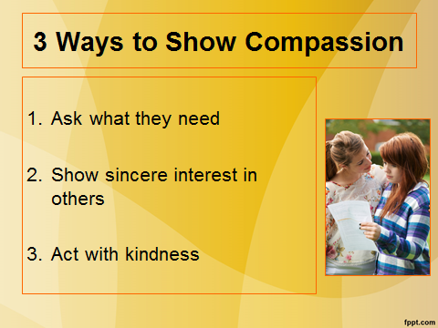
Your child received a Lesson Summary magnet:

If you have a moment, email _____________________________ with any information that might help your child for the next lesson on ________________________. THANK YOU!!

