Social Skills –Parent Note

Your child just completed a social skills lesson. The topic was:
I Can Practice Mindfulness. Your knowledge of this lesson may help you to help your child generalize the skills to other environments.

What he/she learned:

- What is mindfulness? Noticing what is happening right now; paying attention to how our bodies feel; being aware of our emotions and how they feel inside; paying attention to what our mind is doing

- When we are mindful, we can focus more deeply which can help us do better at school, at home, and elsewhere

- Being mindful can also help us calm down when we’re upset

- There are 5 Steps to Practicing Mindfulness

- body still (relaxed, comfortable, not moving around)
- eyes closed (helps to block out distractions)
- stay quiet and listen
- breathe slowly in and out (pay attention to inhales and exhales)
- focus your mind (if your mind starts to wander, bring it back to now – “what’s happening in me and around me?”

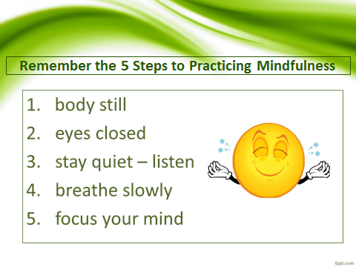
- Using these steps can help us take control of our thoughts and emotions, feel better and do better!

Your child received a Lesson Summary magnet:

If you have a moment, email _____________________________ with any information that might help your child for the next lesson on ________________________. THANK YOU!!

