What’s Happening Today?

Let’s Talk About Practicing Mindfulness

- What is mindfulness?

- Good things happen when you’re mindful – you can focus better and even calm down when you’re upset!

- There are 5 Steps to Practicing Mindfulness

- body still
- eyes closed
- stay quiet – listen
- breathe slowly
- focus your mind

- Doing these things can help us take control of our thoughts and emotions, feel better and do better!

- So what do you think??
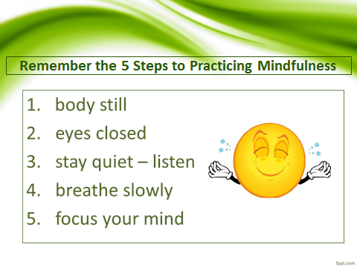
- Get your magnet!

