ACTIVITY: Deep Breathing Exercise
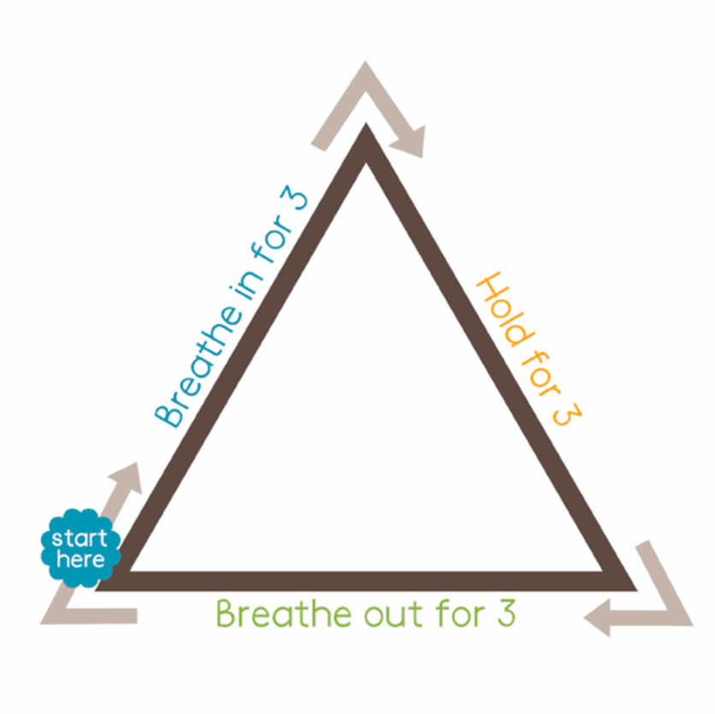
Make a copy of the shape below for each student. Have them put their finger on the start point and trace the shape, following the instructions on each side of the triangle. Repeat several times and ask students how they feel afterwards. https://copingskillsforkids.com/deep-breathing-exercises-for-kids

