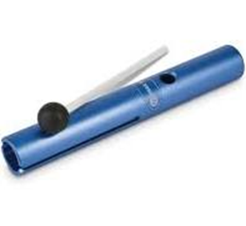
ACTIVITY: Sound Signal (Chris Bergstrom, 2009)
Materials Needed:
- Vibra Tone

OR
- Singing Bowl

PROCEDURE:
- Tell students to get comfortable and sit in a relaxed, mindful position
- Have them close their eyes and focus their minds
- Explain that you’re going to make a sound and that they should try to listen for it as long as it lasts. Tell them to quietly raise their hands when they can’t hear the sound any more.
- Strike the Vibra Tone with the mallet (or use the mallet around the rim of the Singing Bowl)
- When the tone stops, ask the students how they felt while they were listening to the sound. Was it hard to focus? Were they distracted by something else? Who felt peaceful and relaxed?
- Remind students about the mindfulness steps they learned in the lesson, then repeat the activity. Ask students if they felt any differently this time around.

