Social Skills –Parent Note

Your child just completed a social skills lesson. The topic was:
I Can Handle Homework. Your knowledge of this lesson may help you to help your child generalize the skills to other environments.

What he/she learned:

- Homework is a part of school life – even if we don’t really like to do it

- There are ways to make homework easier

- There are 3 TIPS FOR HANDLING HOMEWORK

- Get Organized (materials, work space, time)
- Stay Focused (reduce distractions, make a “to do” list, take short breaks, refocus)
- Get It Done! (check your work, pat yourself on the back, put it where it belongs)

- Using these tips can help us complete homework more easily and efficiently

Your child received a Lesson Summary magnet:
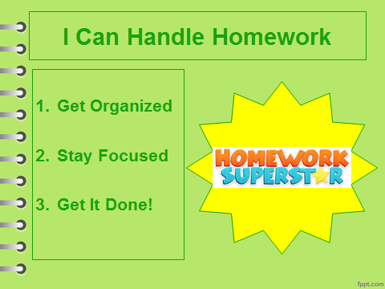

If you have a moment, email _____________________________ with any information that might help your child for the next lesson on ________________________. THANK YOU!!

