ACTIVITY: DESIGN YOUR HOMEWORK SPACE!
Tell students to pretend they’ve been given a bunch of money to design the homework space of their dreams. Give them paper, pencils, and markers and encourage them to draw a workspace that includes the elements they’ve learned about in the lesson. Remind them to organize everything so that they have what they need at their fingertips. Emphasize the need to reduce distractions. Have them share their drawings at the end of the session.
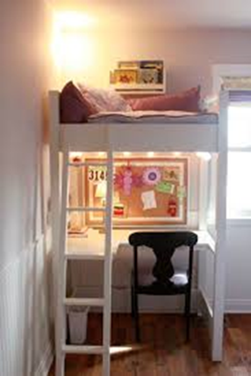

ACTIVITY: BOOKBAG CLEAN-OUT!
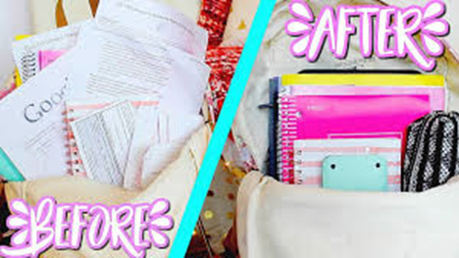
Have students bring their bookbags to the social skills session. Provide a big trash can in the center of the group and let kids sit on the floor as they go through their bags. Give them different colored folders and markers to label one for each class. Have them organize their papers into the folders, disposing of unnecessary papers in the trash. For fun, take iPad pictures of the befores and afters.

