Social Skills –Teacher Note

Your student just completed a social skills lesson. The topic was:
I Can Accept Consequences. Your knowledge of this lesson may help you to help your student generalize the skills to other environments.

What he/she learned:

- A consequence is the result of an action or a situation. It could be because of a mistake we make, or something we say or do that we shouldn’t
- Everyone makes mistakes – we can learn from them!
- Sometimes our mistakes have consequences – whether they happen at school or at home
- There are 4 STEPS TO ACCEPTING CONSEQUENCES:
- Look at the person
- Say “okay”
- Stay calm
- Don’t argue
- Doing these steps helps us to take responsibility for our actions and accept the consequences

Your student received a Lesson Summary magnet:
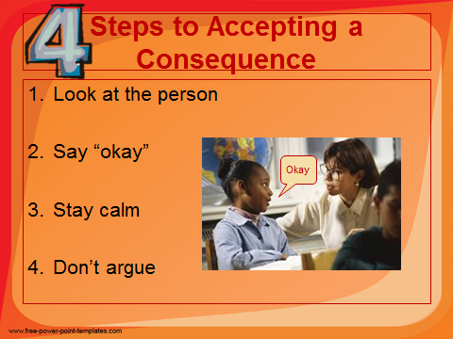

If you have a moment, email _____________________________ with any information that might help your student for the next lesson on ________________________. THANK YOU!!

