What’s Happening Today?

Let’s Talk About How to Accept Consequences

- What is a consequence?

- Sometimes we make mistakes that can lead to consequences

- What are possible consequences for mistakes we might make at school? At home?

- There are 4 Steps to Accepting Consequences

- Look at the person
- Say “okay”
- Stay calm
- Don’t argue

- So what do you think??
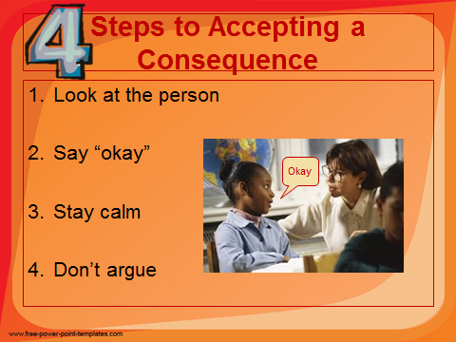
- Get your magnet!

