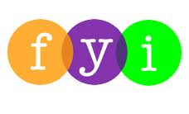
Social Skills –Teacher Note

Your student just completed a social skills lesson. The topic was:
I Can Handle Peer Pressure. Your knowledge of this lesson may help you to help your student generalize the skills to other environments.

What he/she learned:

- What is a “peer”; what is “peer pressure”?

- Peer pressure can be POSITIVE if it gets you to do something worthwhile or it can be NEGATIVE if it gets you to do something you feel isn’t right

- There are always consequences for our actions. Negative peer pressure can result in outcomes we didn’t expect or want

- There are 7 Ways to Handle Peer Pressure:
- Learn to say “no”
- Make an excuse and leave
- Make your own decisions
- Avoid people and situations you’re not comfortable with
- Talk to your parents and trusted friends
- Think about possible consequences for your actions
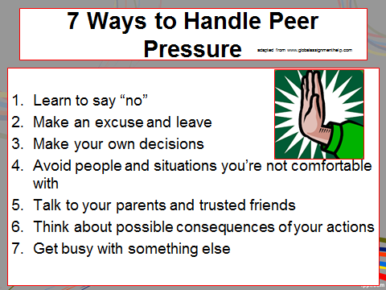
- Get busy with something else

Your student received a Lesson Summary magnet:

If you have a moment, email _____________________________ with any information that might help your student for the next lesson on ________________________. THANK YOU!!

