This week I might try:

To handle peer pressure

I’ll try to remember that there are 7 ways to respond to peer pressure.

I can keep track of what I’m learning on the chart below:

If I’m confronted peer pressure this week, I’ll try to: | Day  1 | Day  2 | Day  3 | Day  4 | Day  5
- say “no”

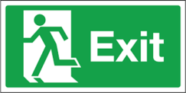
- make an excuse and leave

- make my own decisions

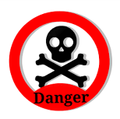
- avoid people and situations I’m not comfortable with

- talk to my parents or a trusted friend

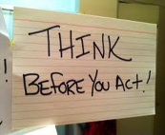
- think about the consequences of my actions

- get busy with something else

