[Child’s name] Goes to the Beach

My name is [child’s name]. I am going to the beach!

I will hear waves, birds, and kids laughing.

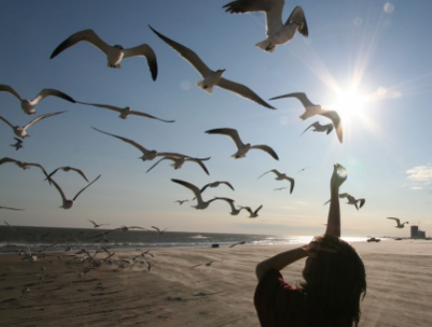
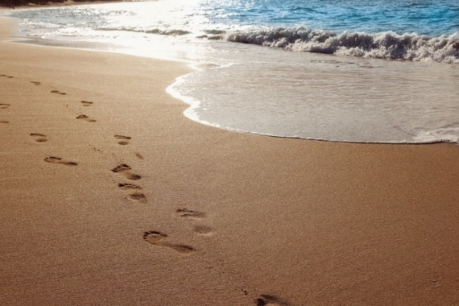

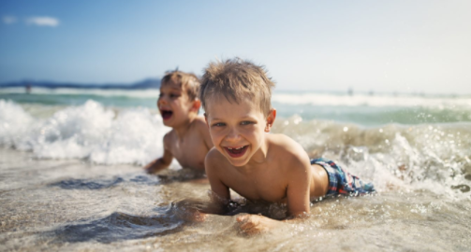

I will feel the sand.
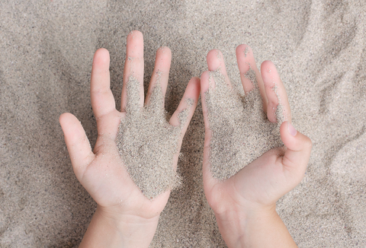

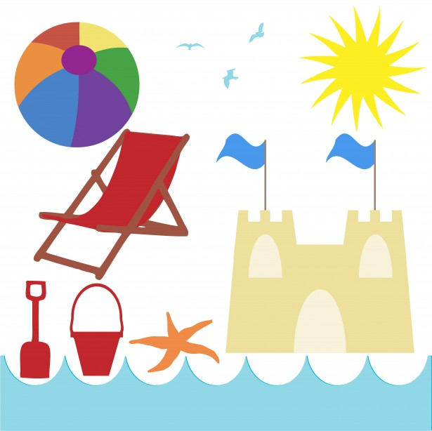

I will see soooooo many fun things.

Let’s see what I can find:

Sun Ball Chair
Bucket Starfish Birds
Shovel Sandcastle

There are rules at school. Rules like listen to my teacher, and quiet lips. I follow the rules so I can have fun with my friends.

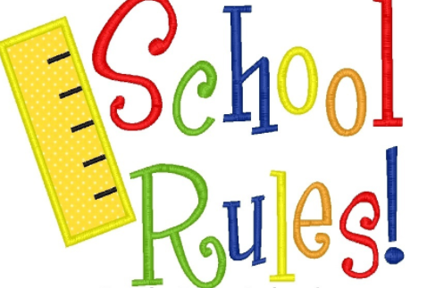

Guess what??????
There are rules at the beach tooooo! Beach rules keep me safe so I can have fun.

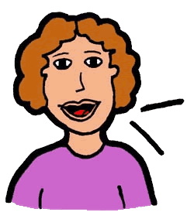
Here are the beach rules:
- Listen to my mom’s words.

- Hold mom’s hand to go into the water.

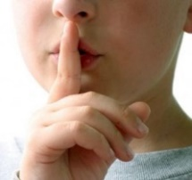
- Quiet lips.

- Hands to self. 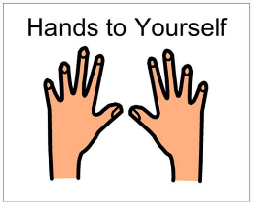

- ___________________________
- ___________________________
- ___________________________

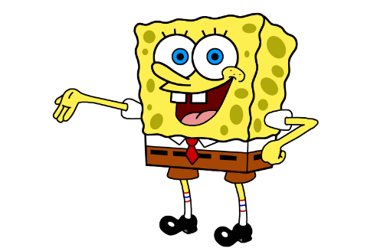

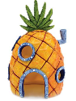
Sponge Bob has rules too!
- Live in a pineapple.

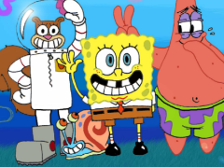
- Take turns with Patrick and Sandy, and all my friends.

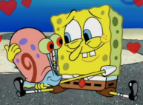
- Keep Gary safe.

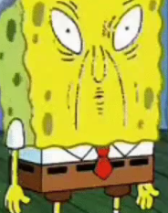
- Quiet sponge lips.

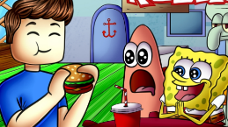
- Be a good listener at Krusty Krab.

I will try hard to follow the beach rules, like the rules at school, and like Sponge Bob!
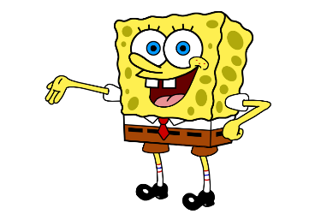
You can do it ______!!

