I am Graduating

Insert image of student

Insert image of school here

On [insert date], I will graduate from [name of school].

When students turn 21, they have to graduate from school. It is the rule.

Graduation means that [insert school name] is finished.

Insert Image of current School – insert ‘X’ over the school

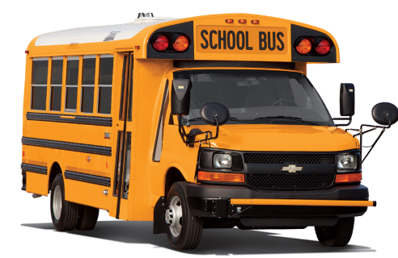
I will start to ride the BART VAN to [name of work site] to go to Work
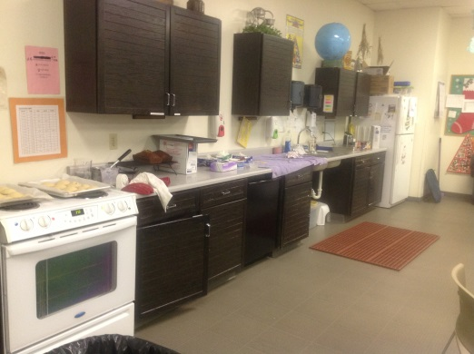
Substitute right image with person’s work site
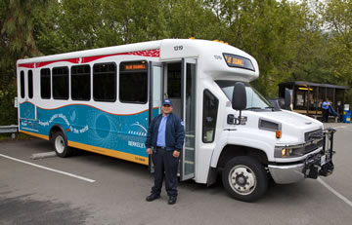

I will work at [name of site] on Monday, Tuesday, Wednesday, Thursday, and Friday.
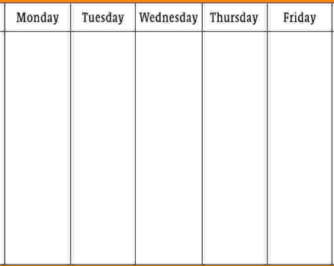

I will work with my new friends at [work site name] and do a good job!!!

I will ride the BART VAN home at the end of my work day.

