A New School
NEXT week, I am going to [name of off-site work school] program on [day of the week].
Insert Student Image Here
Insert Site Image Here

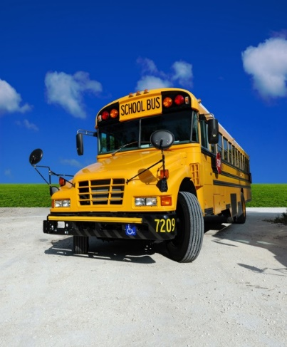
I will ride the bus to [name of site]

I will get off at [name of site] and meet [name of adult] there
Insert image of adult meeting student

I will get to work All Day with friends at [name of school]
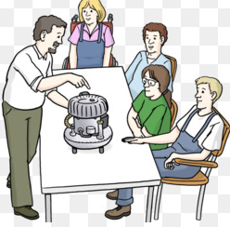

And eat lunch at [name of work site] too.

I like working and spending time with new friends at [name of work site]

When I am done working at [name of work site] for the day I will be picked up by the bus and will go home.
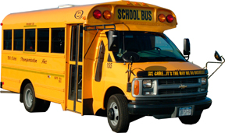

I will leave [name of current school] and go to my work school on [List the days the student goes off-site]
Insert image of work site
Insert image of home school

