A Day at My ‘Work School’

I am going to [name of work place and insert photo].
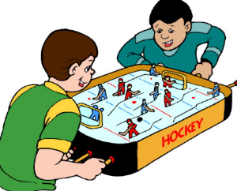
Work School is fun!
I get to be with new friends.

Today, I will leave at [insert time]

I will miss [insert class]. That is OK.
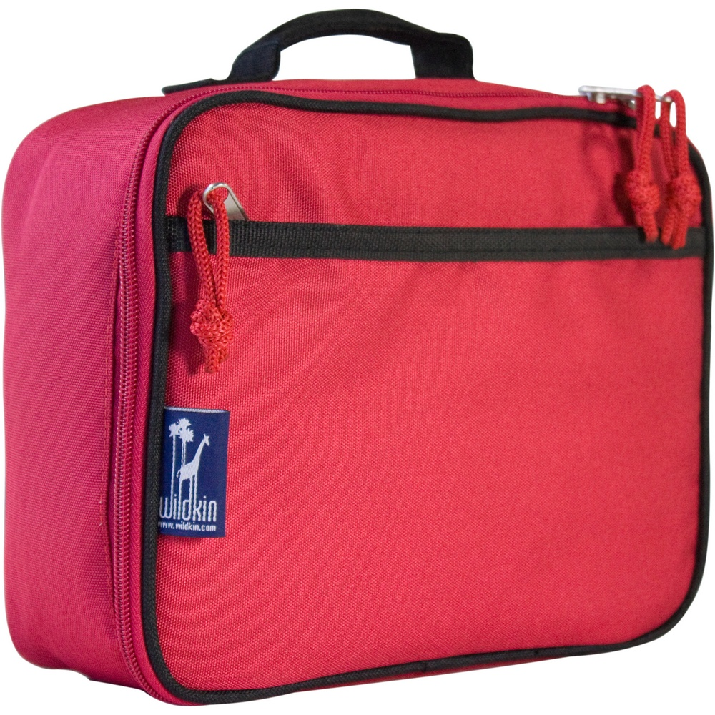

I will also eat my lunch at work school today.

I will eat lunch with my friends at [work place]

After lunch, I will come back to [name of school]

Then I help[name] do my scheduled job. [insert image]

I will do a great job at work school! [can insert special interest person/character]

