Social Skills –Teacher Note

Your student just completed a social skills lesson. The topic was:
I Can Turn My Bad Day into a Better One! Your knowledge of this lesson may help you to help your student generalize the skills to other environments.

What he/she learned:

- Every day is different: some days are great, some days are okay, and some days can be pretty bad

- Everyone has bad days but the good news is that we can turn a bad day into a better one

- There are 4 strategies we can use to turn a bad day into a better one:

- talk to someone
- spend time doing something you like
- focus on the positive
- remember that today will pass

- So what do YOU think? discussion question
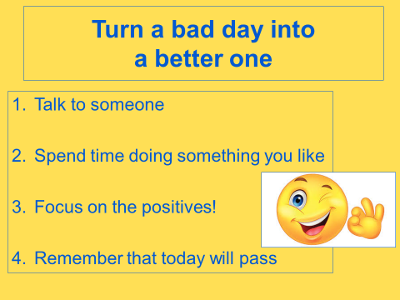

Your student received a Lesson Summary magnet:

If you have a moment, email _____________________________ with any information that might help your student for the next lesson on ________________________. THANK YOU!!

