What’s Happening Today?

Let’s Talk About Ways to Turn a Bad Day into a Better One!

- Every day is different: some days are great, some days are okay, and some days can be pretty bad

- Everybody has bad days

- Good news: We can turn a bad day into a better one!

- 4 Things we can do to turn a bad day into a better one

- So…what do YOU think?

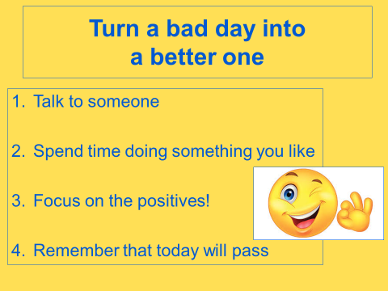
- Get your magnet!

