Social Skills –Parent Note

Your child just completed a social skills lesson. The topic was:
I Can Follow Directions. Your knowledge of this lesson may help you to help your child generalize the skills to other environments.

What he/she learned:
- There are different types of directions given at school.

- It’s important to follow directions at school.

- There are positive outcomes when students follow directions (i.e. students finish work, teachers and parents are happy, etc.)

- Students learned 6 things to do to help them follow directions:

- Listen carefully to what the teacher is saying
- Check for visual cues
- Say (or think) “okay”
- Ask questions if I didn’t hear or I don’t understand
- Repeat the direction to myself and picture me doing it in my mind
- Follow the direction as soon as I can!

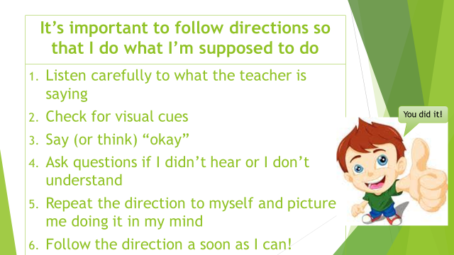
- So what do YOU think? discussion question

Your child received a Lesson Summary magnet:

If you have a moment, email _____________________________ with any information that might help your child for the next lesson on ________________________. THANK YOU!!

