What’s Happening Today?

Let’s Talk About Following Directions

- What are some directions you hear at school?

- Why is it important to follow directions at school?

- What happens when you follow directions and do what you’re supposed to do?

- 6 things you can do to help you follow directions

- So what do YOU think?

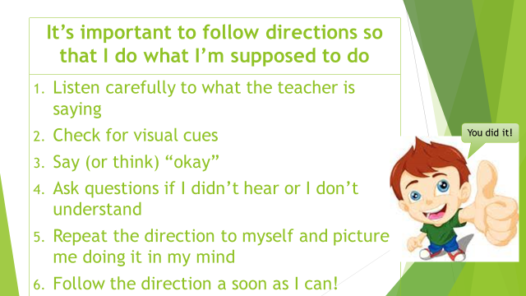
- Get your magnet!

