This week I might try:

To Follow Directions

I’ll try to remember that there are 6 things I can do to help me follow directions.

I can keep track of what I’m learning on the chart below:
I Can Follow Directions: | Day  1 | Day  2 | Day  3 | Day  4 | Day  5
- Listen carefully to what the teacher is saying

- Check for visual cues

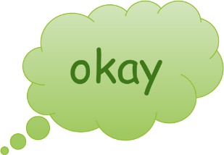
- Say (or think) “okay”

- Ask questions if I didn’t hear or I don’t understand

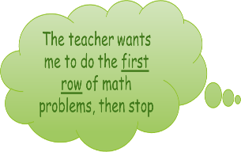
- Repeat the direction to myself and picture me doing it in my mind

- Follow the direction as soon as I can!

