Social Skills –Parent Note

Your child just completed a social skills lesson. The topic was:
I Can Ask for Help. Your knowledge of this lesson may help you to help your child generalize the skills to other environments.

What he/she learned:
- We encounter different problems at school and elsewhere.

- Sometimes we can fix these problems on our own, but sometimes we might need help.

- There are 4 steps we can take to ask for help:

- Figure out IF you need help
- Think about WHO can help
- Ask for help the right way
- Thank him or her for the help

- So what do YOU think? discussion question
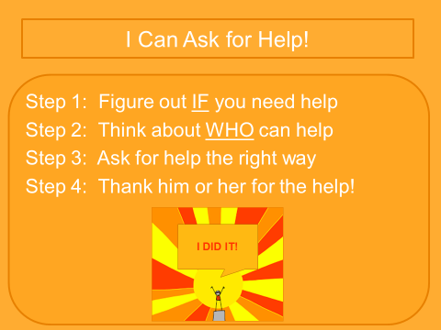

Your child received a Lesson Summary magnet:

If you have a moment, email _____________________________ with any information that might help your child for the next lesson on ________________________. THANK YOU!!

