This week I might try:
To Ask for Help

I’ll try to remember that there are 4 things I can do to ask for help.

I can keep track of what I’m learning on the chart below:

I Can Follow Directions: | Day  1 | Day  2 | Day  3 | Day  4 | Day  5
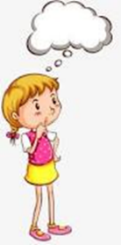
- Figure out IF I need help

- Think about WHO can help

- Ask for help the right way

- Thank him or her for the help

