Social Skills –Teacher Note

Your student just completed a social skills lesson. The topic was:
Everyone is Different. Your knowledge of this lesson may help you to help your student generalize the skills to other environments.

What he/she learned:

- The world is full of people who are different.

- Being different is what makes us special.

- Sometimes when people look different from us, we might make a judgment about them.

- That judgment might keep us from making a new friend!

- There are 5 strategies we can use to learn to accept the differences in others:

- Keep in open mind
- Introduce yourself
- Learn more about the person
- Find things you have in common
- Accept your differences!

- So what do YOU think? discussion question

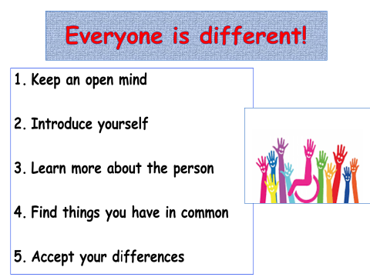
Your student received a Lesson Summary magnet:

If you have a moment, email _____________________________ with any information that might help your student for the next lesson on ________________________. THANK YOU!!

