This week I might try:
To accept that Everyone is Different

I’ll try to remember that there are 5 ways I can learn to accept the differences in others.

I can keep track of what I’m learning on the chart below:

I Can Accept that Everyone is different | Day  1 | Day  2 | Day  3 | Day  4 | Day  5
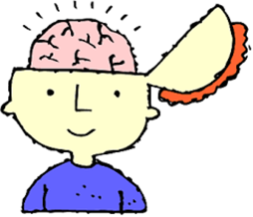
- Keep an open mind

- Introduce yourself

- Learn more about the person

- Find things you have in common

- Accept your differences!

