[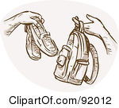](http://www.google.com/url?sa=i&rct=j&q=&esrc=s&source=images&cd=&cad=rja&uact=8&ved=0ahUKEwiK7a-I77nJAhVISCYKHRw8BMoQjRwIBw&url=http%3A%2F%2Fwww.clipartof.com%2Fgallery%2Fclipart%2Fshoes_10.html&bvm=bv.108194040,d.eWE&psig=AFQjCNH6lJ2AxMSCPmHHkR0n7eB_DlC1xA&ust=1449032000506081)[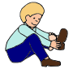](http://www.google.com/url?sa=i&rct=j&q=&esrc=s&source=images&cd=&cad=rja&uact=8&ved=0ahUKEwjt6PG57rnJAhVHSyYKHb1bCE0QjRwIBw&url=http%3A%2F%2Flessonpix.com%2Fpictures%2F44182%2FPut%2520on%2520Shoes&bvm=bv.108194040,d.eWE&psig=AFQjCNEI4KPzWeUVfRoScD2KHJTJ-92I6Q&ust=1449031845224543)[](http://www.google.com/url?sa=i&rct=j&q=&esrc=s&source=images&cd=&cad=rja&uact=8&ved=0ahUKEwiA6dP47bnJAhXJRiYKHbWBCsEQjRwIBw&url=http%3A%2F%2Fwww.clipartpanda.com%2Fcategories%2Fopen-storybook-clipart&bvm=bv.108194040,d.eWE&psig=AFQjCNG_EjCRzvQ-k80haS-xkrCYyuSpbg&ust=1449031695053505)[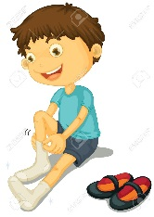](http://www.google.com/url?sa=i&rct=j&q=&esrc=s&source=images&cd=&cad=rja&uact=8&ved=0ahUKEwis4_av7bnJAhXLPiYKHduLDcIQjRwIBw&url=http%3A%2F%2Fhdimagelib.com%2Fboy%2Bputting%2Bon%2Bclothes&bvm=bv.108194040,d.eWE&psig=AFQjCNG8Y96J7eExnVEvENSm8ikQ2jj_Qg&ust=1449031475804761)

1. Get on the bus[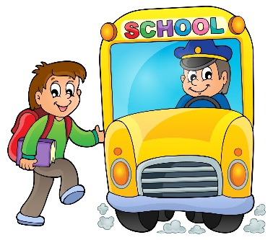](http://www.google.com/url?sa=i&rct=j&q=&esrc=s&source=images&cd=&cad=rja&uact=8&ved=0ahUKEwiByc-j7LnJAhUCTCYKHX-_D0MQjRwIBw&url=http://imagebasket.net/623-cartoon-picture-of-school-bus-driver.php&psig=AFQjCNERcYJ_VQM50McqetICecsqy6C-PQ&ust=1449031271289232)
2. Put on slippers
3. Read my book
4. Put on shoes when ____ gets off.
5. Put slippers in bag