What is personal space?



Let me show you. Stand with your arms out.

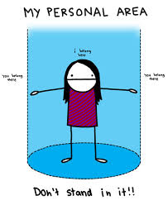

.

The blue area is your personal space.




People should not stand any closer than your fingertips when they are talking, playing, or walking in a line.

