**What Should I Do When I’m Really Upset?**

Usually everything at school is just fine. Kids listen to teachers and do work, share, and play.

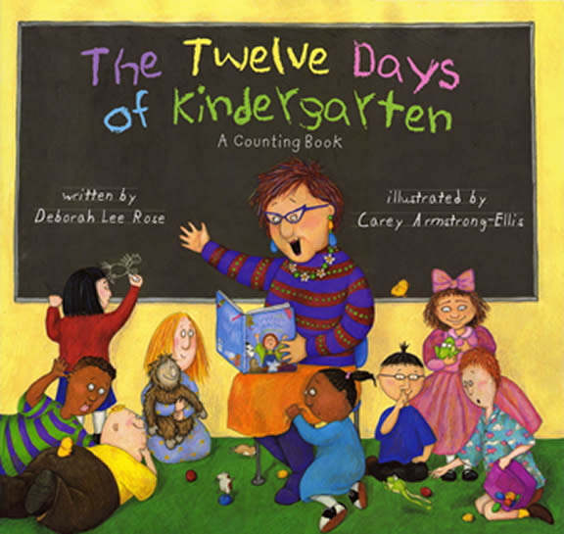

But, sometimes a kid can get really upset. I do!



Sometimes I just want to scream.

Sometimes I just want to fall down.

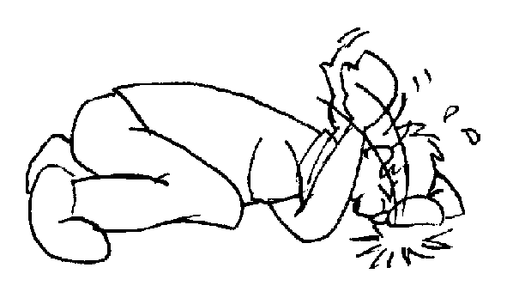

Sometimes I just can’t move.

When I feel like that I can do things to feel better!

I can squeeze my hands and pretend I’m squeezing an orange!

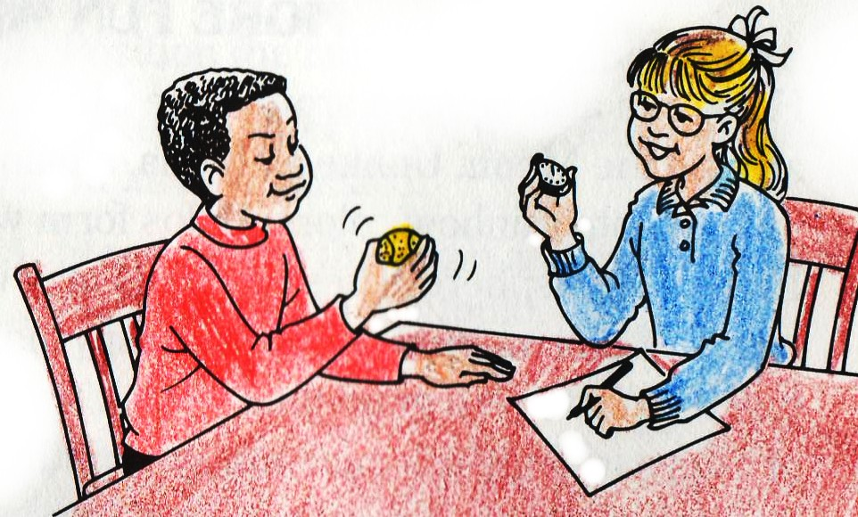

THEN I GET THE TEACHER TO HELP ME FEEL BETTER. SHE WILL KNOW WHAT TO DO.



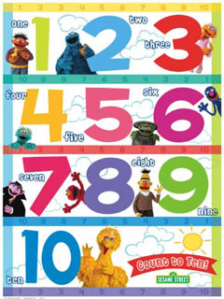I can count to 10 slowly.

THEN I GET THE TEACHER TO HELP ME FEEL BETTER. SHE WILL KNOW WHAT TO DO.



I can get quiet and still and pretend I’m in a shell like a turtle.

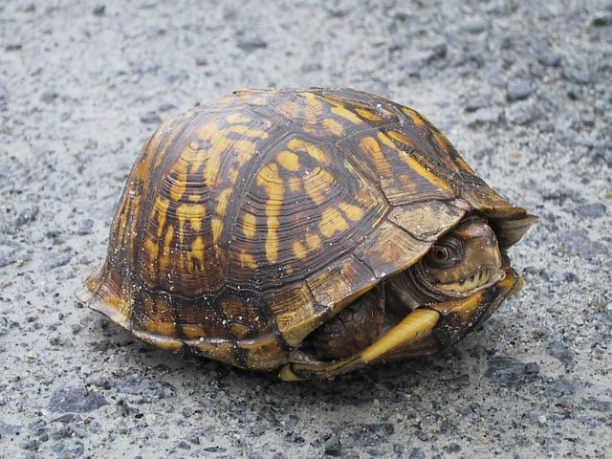

THEN I GET THE TEACHER TO HELP ME FEEL BETTER. SHE WILL KNOW WHAT TO DO.



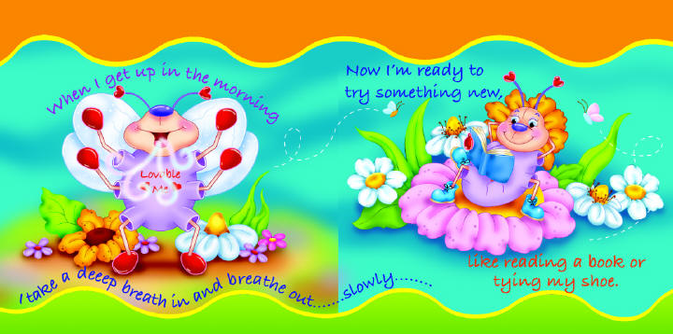I can remember this rhyme and breathe in and out slowly.

THEN I GET THE TEACHER TO HELP ME FEEL BETTER. SHE WILL KNOW WHAT TO DO.

