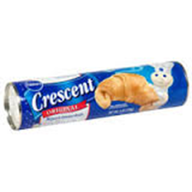
Yummy Sausage Squares
INGREDIENTS:

2 tubes crescent rolls

1 pound breakfast sausage

1 (8-ounce) package cream cheese,
softened

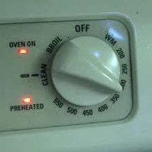
DIRECTIONS:
- Preheat oven to 325°.

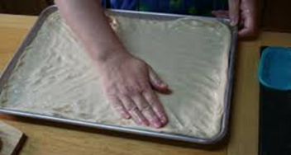
- Open 1 can of crescent rolls. Spread out dough on baking sheet, pressing perforations to seal.

- Spread cream cheese over dough on baking sheet.

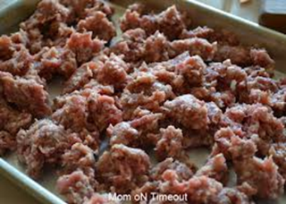
- Crumble and spread sausage over cream cheese.

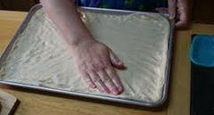
- Top with second can of crescent roll dough, smoothing over layers and pressing perforations to seal.

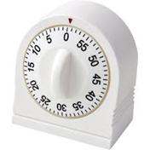
- Bake 12 to 15 minutes until golden brown.

