Relaxation Menu
- Relax in the bean bag chair

- Squeeze my hands 5 times

- Slowly count to 10

- Go into my shell like a turtle
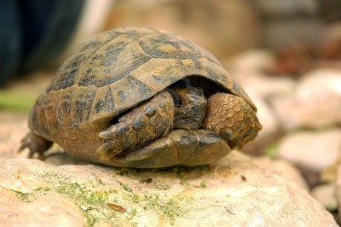
- Take 5 deep breaths
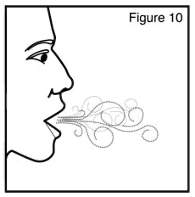 The Watson Institute , 2013

