Lunch Time at School

I started a new school! And it is pretty cool! My favorite things are:

_______________________, _________________________, and _____________________.

I have my own desk area and things to do that I like. I always know what I’m doing and my teachers help me out if I get confused or frustrated – all I have to do is ask!!

We have lunch at my new school. Sometimes I feel funny about lunch. Sometimes it bothers me to go because I have to sit in a certain place.

At school the adults have to tell you where to sit so you are safe and they know where you are.

I want to feel OK where I sit….so my teachers are giving me a SEAT SHEET – it is pretty cool. When I have my SEAT SHEET, I can feel safe. It has my favorite cars on it!

They have things to say about the lunch seat!


Hey, it’s all about Teamwork! I learned that you and your teachers are a team and can help you with your seat! I’ll help ya too! Just sit on me!


Hi,
Doc here – I am a Doctor and I can take care of you while you are in your assigned seat – just sit on me!!!

Hey…sit on the assigned seat – it is your Peet stop! (Pit stop!)

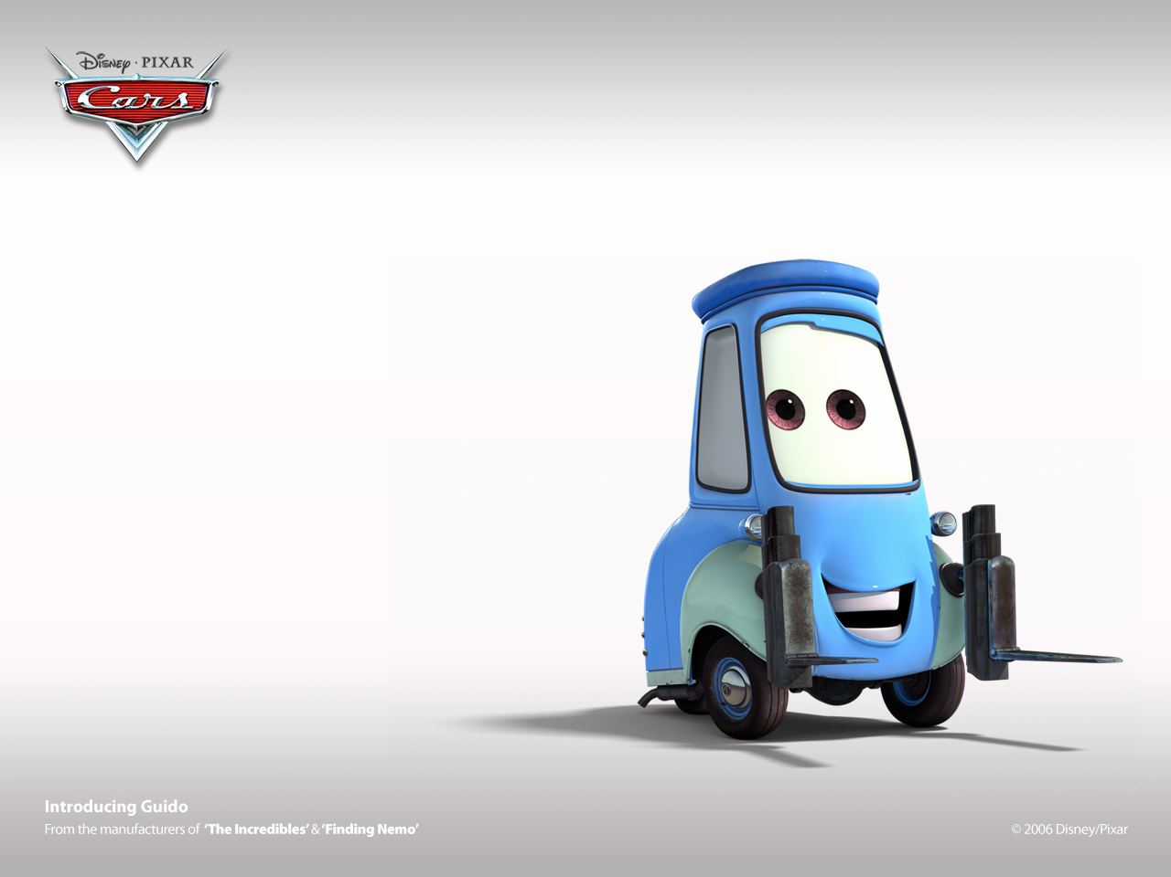

I’m going to try hard to sit on my SEAT SHEET. If I can sit on my assigned seat then I can start collecting Car cards!! But if I have a hard time I will sit somewhere safe and tell an adult. Then I’ll try harder the next time and get a car card.

