

Going to the Doctor’s Office

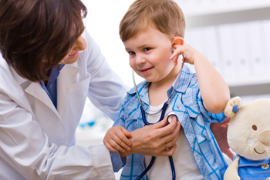

Sometimes I have to go to the doctor’s office.

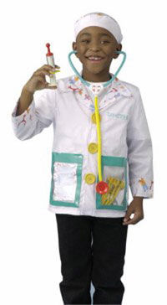

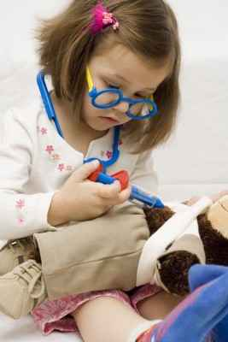

Sometimes I go to the doctor’s when I am sick, but usually I go to the doctors just so they can check that I am growing big and strong!

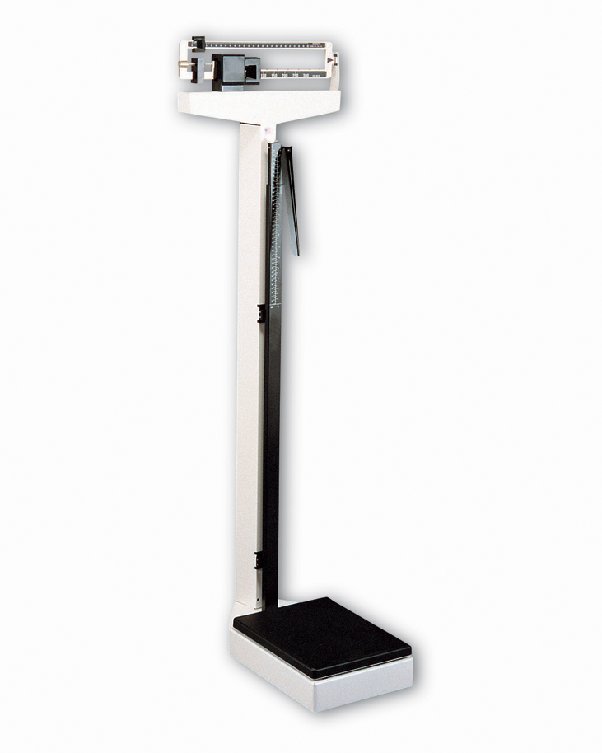

All the people at the doctor’s office see how brave I am when I step on the scale to see how big and tall I am getting. The doctor might ask me to take off my shoes to step on the scale.

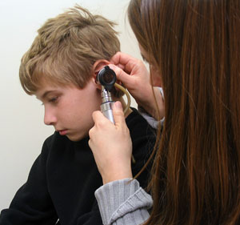

Sometimes the doctor shines a light in my ears, nose and eyes. This is to make sure I am healthy and clean. They may also tap on my knees or feet. This makes my leg jump! It’s a silly feeling.

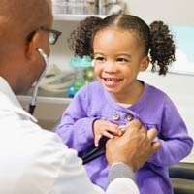

Usually the doctor will use their stethoscope to listen to my heart beat and my lungs breathing in and out. Sometimes they let me listen too!

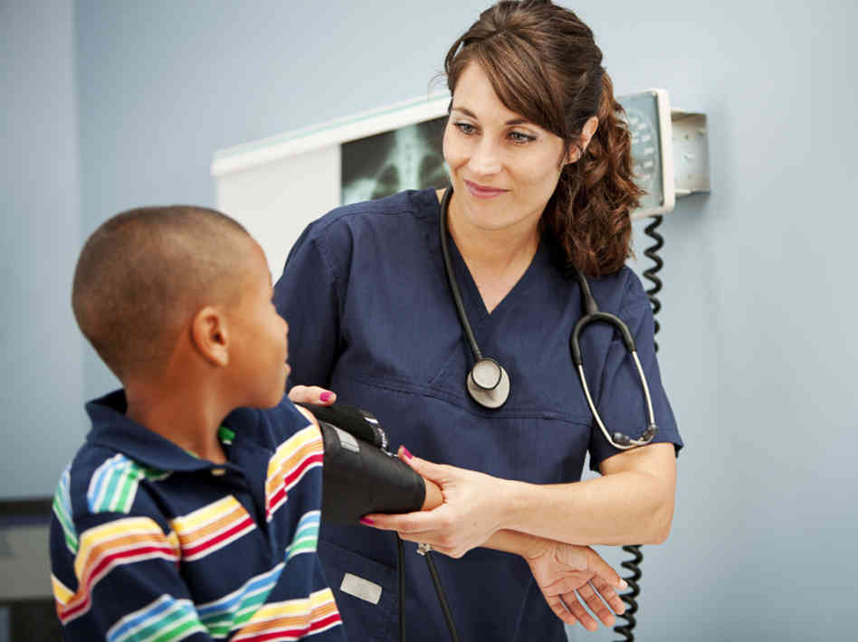

Sometimes the doctor has to put a blood pressure cuff on my arm. This is to make sure I am strong and healthy. The cuff gives my arm a hug!





When the cuff gives my arm a hug, I can close my eyes and count. Or I can sing a song. This will not hurt me and it tells the doctor how healthy I am!

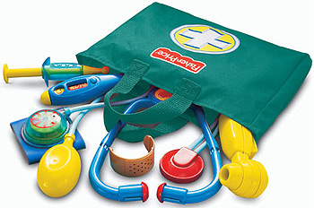

I can practice this at home!! The people at the doctor’s office are so proud when they see how brave I am. Mom and dad are proud too!





When it’s time to leave the doctor’s, I sometimes get a special treat, like a book! I also get a big hug from mom or dad, for being such a good patient!



I like going to the doctor’s office so I can show them how big and strong I’m getting!