FRIENDS
_____ Elementary School is a great school.
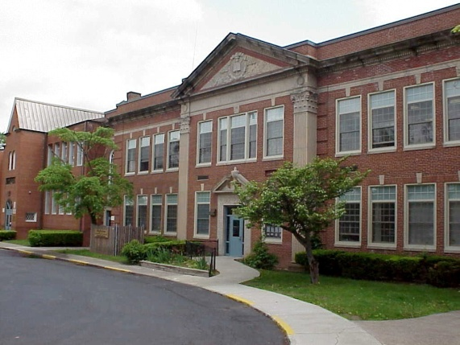

I go there. I have friends in my classes. I love talking with my friends. Sometimes I really like to be with certain friends. I like to eat with them; I like to be partners with them.
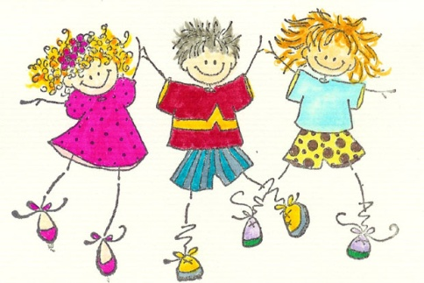

Sometimes though, you have to be careful. Sometimes a friend can feel like someone talks to them TOO much. Sometimes the friend feels like they want to be with someone else for a little bit, or they want to be alone a little bit.
I have to remember to be careful and not always bother Jill. Then we can stay friends
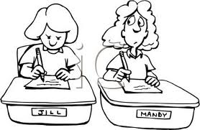
Mandy keeps talking to me all the time. I like her but sometimes I like to work alone!

Friends don’t want to be with each other ALL the time and that is OK. I have to be OK with that and my friend has to be OK with that. Know what might happen if a person is with a friend too much? They might not want to be your friend anymore.
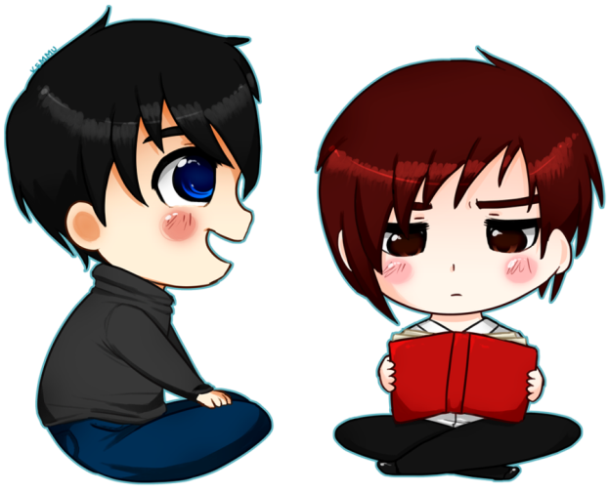
I don’t think I can be Joey’s friend anymore. He wants to be with me all the time. Sometimes is great, but this is too much.

So..kids just have to remember to BALANCE a friendship. Balance means not too much, not too little: Just right. Sort of like the old story of the 3 Bears. You have to have it “Just right!”

Balanced

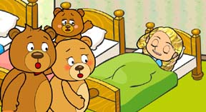
This bed is JUST RIGHT!

I’m going to remember : DON’T ALWAYS talk to ONLY ONE friend. TALK TO DIFFERENT FRIENDS. And, it is a good idea to ask a friend too. Like, “would you like to _____?” If they say ‘not right now’ that is fine with me because there are many kids in my school!

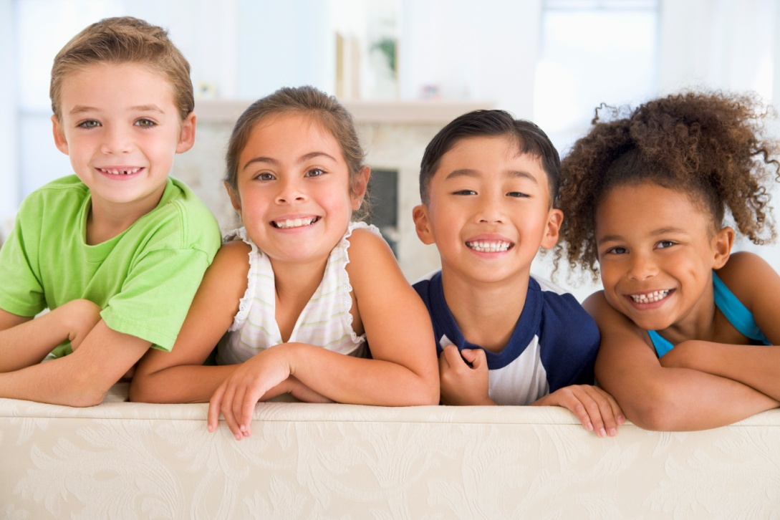
Me too! I talk to lots of different kids in my school!
I have lots of friends. I don’t just talk to one all the time!

