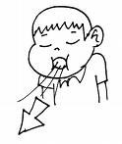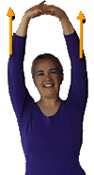[](http://gallery.photo.net/photo/3929885-lg.jpg)

**Take 5 deep breaths.**

**Stretch your arms in the air and breathe 5 times.**

**Do 5 chair pushups.**

**Push your hands together and count to 5. Stop. You can do this 3 times.**

CALMING and RELAXING My MUSCLES

YOU CAN START AGAIN IF YOU WANT!