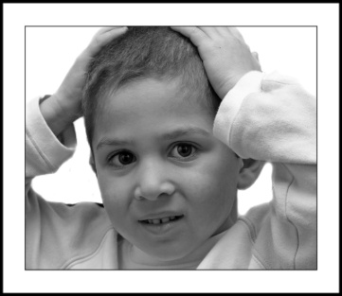[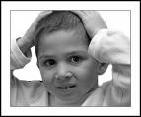](http://gallery.photo.net/photo/3929885-lg.jpg)

**Try it!**

**Push on your head and count to 5. Stop. You can do this 3 times.**

CALMING and RELAXING My MUSCLES





**Now sit on your hands as long as you can. You can start everything again if you want!**

**Push your hands together and count to 5. Stop. You can do this 3 times.**