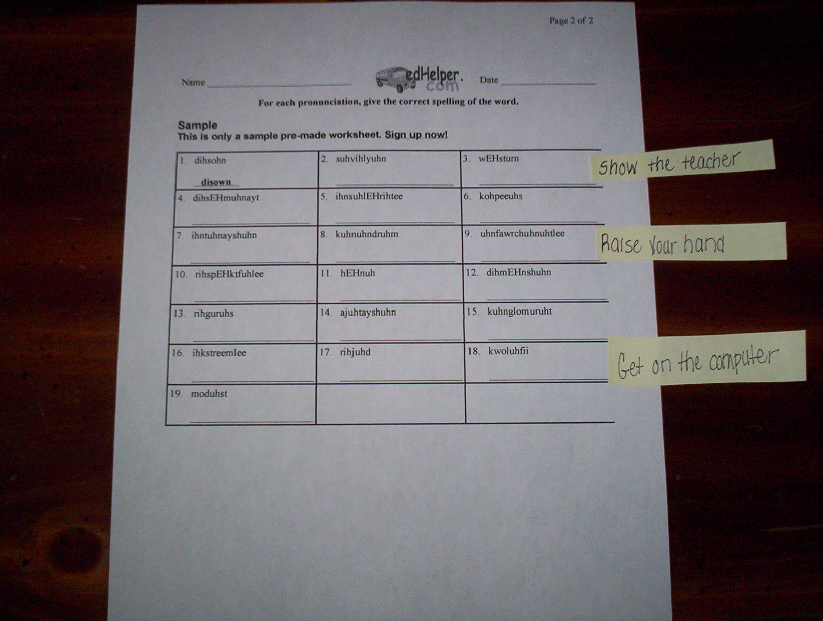

Chunk the work with embedded reinforcers to promote independence.

