Stopping What I’m Doing and Making it OK

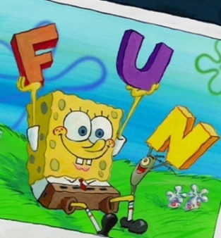 My name is [student’s name] and I like lots of characters on T.V. Here is SpongeBob. He likes to have fun just like me. Here is SpongeBob and Plankton having fun together.

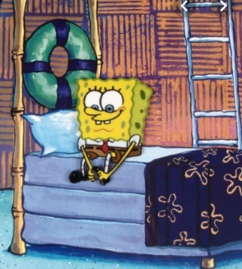Sometimes SpongeBob has to stop what he likes and do other things. He might have to make his bed.

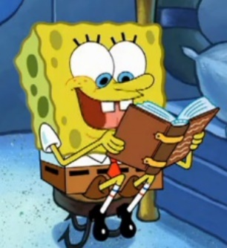He might have to read a book.

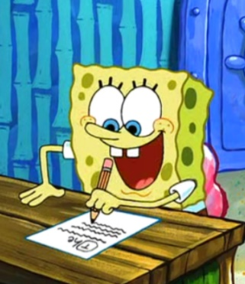Sometimes he might have to do his school work.

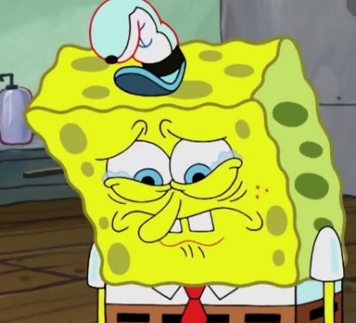Sometimes it makes SpongeBob sad that he has to stop what he is doing.

**It makes me sad to stop what I’m doing!**

Sometimes his friend Gary has to tell him 2 times to stop.

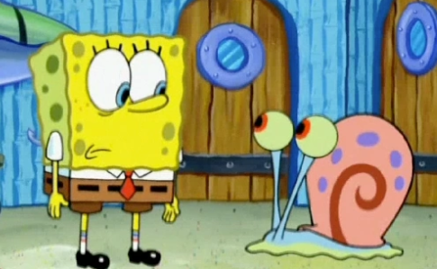

Spongebob you have to stop and do other things now. You can come back to having fun then**.**

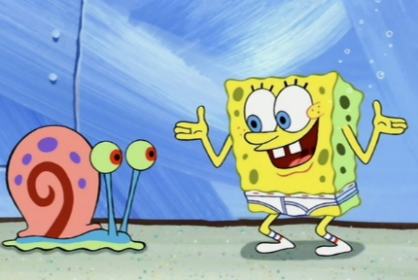That can make SpongeBob sad. But he just tells Gary he feels sad and then Gary helps him to stop and start his other work. Gary still likes SpongeBob. Gary just has to remind him.

I can do it Gary. I’ll stop, do the next thing, then have fun!



SpongeBob does his work then goes back to having fun.