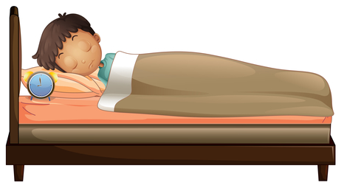
Place child’s face here

SLEEPING IN MY OWN COMFY BED

My name is [child’s name]. Pretty soon it will be my birthday. I am turning _____ years old.

Insert child’s picture here holding up the number of fingers for his/her birthday

When I am _____ years old, I will sleep in my own comfy bed. Now that I am getting bigger, it is my job to sleep in my own comfy bed. Sleeping in my own comfy bed shows that I am growing up, getting braver, and getting stronger.
Place child’s face here
Place child’s face here

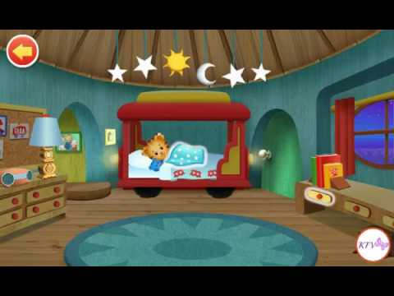
Daniel Tiger is [child’s age] years old. He is growing up, getting braver and stronger. Daniel Tiger sleeps in his own bed.

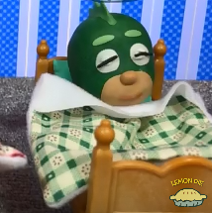
Gekko, Catboy and Owlette sleep in their own beds too. They are [child’s age] years old, brave and strong too.

[caretaker’s name] helps me get ready for bed. I take a bath sometimes. I read a story.

Place photo of parent and/or caretaker reading story to child
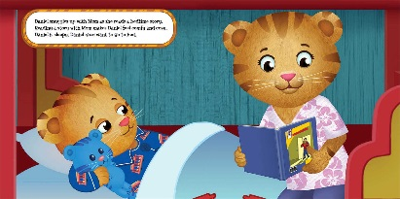

My mommy [or caretaker name] will cover me up then give me 5 cuddles. 1-2-3-4-5
She[caretaker pronoun] will say Good Night [child’ name] . I love you so much. I can say Good night too. Then I can hold my [favorite item] and give him cuddles. I can close my eyes. My mommy [or caretaker’s name] will leave my room.

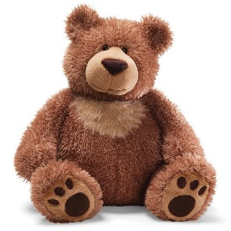

Can insert picture or image of child’ favorite item

If I feel scared I can say to myself, 'Scared is just a feeling.' I can close my eyes and picture my mommy [caretaker’s name] giving me cuddles. I can snuggle my [favorite item] until I feel calm and safe again. I am growing up. I am getting braver. I am getting stronger. It is important to keep trying to stay in my comfy bed.
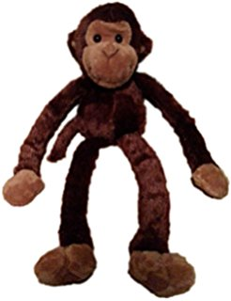
Can place image of child’s favorite item here
Place photo of child’s face here

I know my mommy [ or caretaker name] is watching TV or doing dishes or going to her [caretaker pronoun] bed to sleep. That is what grown-ups do at night after I go to bed. It’s OK. I am safe in my comfy bed.
I am growing up. I am getting braver. I am getting stronger
Can place child’s face over image

In the morning my mommy [or caretaker’s name] will say “Good Morning [child’s name].” When I sleep all night in my own bed, I feel proud of myself, and my mommy [or caretaker name] feels proud of me too. I know that learning to sleep in my own bed is part of growing up and learning to take good care of myself.
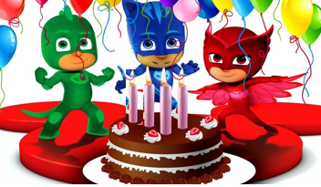
I am growing up, getting braver and stronger.

Can insert a calendar page here of child’s birthday month and date highlighted

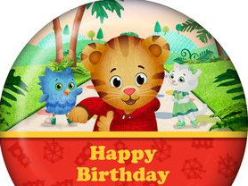

Daniel Tiger and the PJ Masks are helping me to count down to my birthday when I will be [child’s upcoming age] years old, sing happy birthday, eat cake, get birthday presents and sleep in my own comfy bed. Happy Birthday [child’s name]!!!!

Mommy can

