Social Story Book
Ironman needs to go!
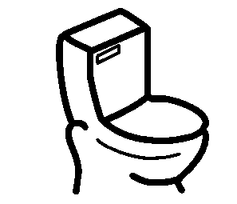

Sometimes Ironman needs to use the bathroom.
He doesn’t want to make his suit rust.


Ironman will tell a teacher when he needs to use the bathroom. Ironman always asks to use the bathroom before he leaves the classroom.

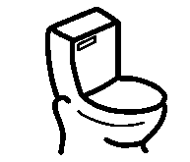
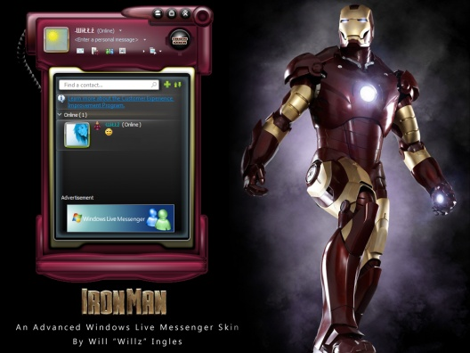
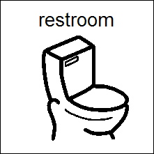
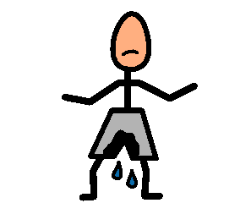

May I use the restroom please?
My teachers will help me if I have an accident. They will take me to the bathroom and help me change.
Ironman will unzip his suit and pull down his underwear to use the bathroom. Sometimes, Ironman needs to sit on the toilet longer to finish going. He can’t save the world if he has to go to the bathroom.
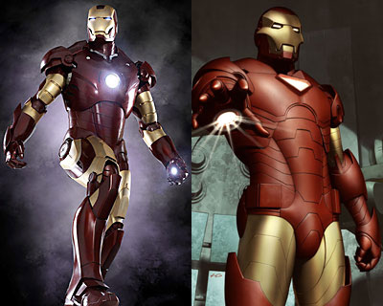
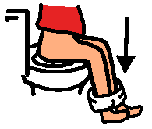

Ironman can’t fight crime with dirty underwear. He needs some toilet paper to wipe his bottom after he uses the toilet.
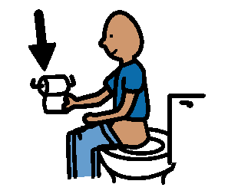
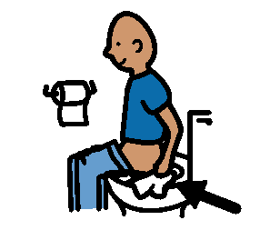
Close the door please. I am using the restroom.
Excuse me.

Ironman needs to flush after he finishes going in the toilet. Then, Ironman will pull up his underwear and suit.

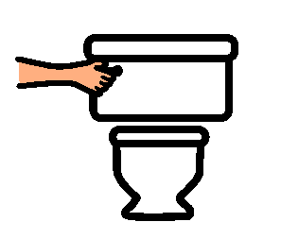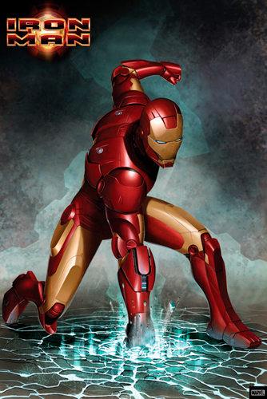
My suit is on. I’m ready for action.
Even Superheroes need to wash their hands. Ironman’s hands are all clean. Ironman is ready for action!
See. I washed my hands.
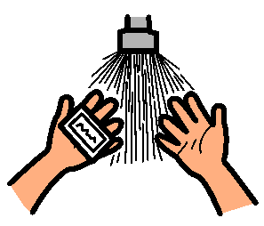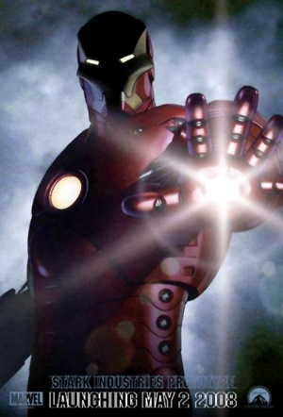
Ironman will line up when he is finished. His teacher is happy when he follows directions! He is a good guy.

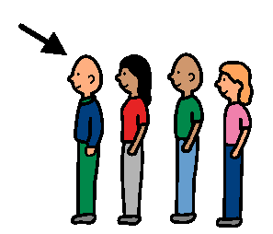
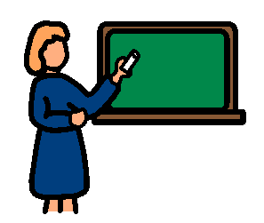
Great job Ironman!

