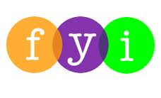
Social Skills –Parent Note

Your child just completed a social skills lesson. The topic was:
I Understand Personal Space. Your knowledge of this lesson may help you to help your child generalize the skills to other environments.

What he/she learned:
- What is “personal space”? (The distance between two people; the space between people that helps them feel comfortable around each other.)

- What happens if people are too close? (They feel uncomfortable, might be scared, might walk away, might not want to hang out, etc.)

- The students looked at different pictures of people too close to others or at an appropriate distance and specified which were “just right” or “too close”.

- Students learned to think of appropriate distances in terms of different colored zones or circles. Each color zone represented a different group of people and changed the way students would interact with them:

FAMILY
FRIENDS
ACQUAINTANCES
STRANGERS

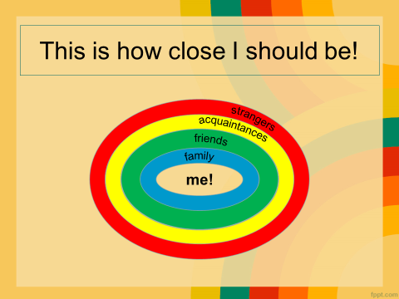
- What can happen when people are at an appropriate distance and given personal space? (you will feel more comfortable, other people will feel more comfortable, may talk to you more, might hang out with you more, you might make more friends, you will be safer with strangers, etc.)

- So what do YOU think?

Your child received a Lesson Summary magnet:

If you have a moment, email _____________________________ with any information that might help your child for the next lesson on ________________________. THANK YOU!!

