What’s Happening Today?
Let’s Talk About Personal Space

- What is personal space?

- What happens if people are too close?

- Let’s look at these pictures. Are they too close or just right?

- Think of appropriate distance as different colored circles that move outward with you in the middle.

FAMILY
FRIENDS
ACQUAINTANCES
STRANGERS

- The different colored circles mean that you will act differently with the people in them.

- When we are at the appropriate distance and give people their personal space, good things can happen!
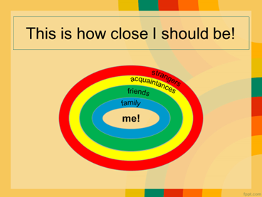

- So what do YOU think?

- Get your magnet!

