Social Skills –Teacher Note

Your student just completed a social skills lesson. The topic was:
I Can Handle Cliques. Your knowledge of this lesson may help you to help your student generalize the skills to other environments.

What he/she learned:
- What is a clique? What’s the difference between a group of friends and a clique?

- There’s usually an assertive person who “leads” the clique. Kids in the clique may act differently than they did before they were members of the clique.

- Why do kids join cliques (shared interests, to be popular, to belong) and why someone might not be part of a clique (may look, act, or dress differently; be new to the school, etc.)

- How it feels to be outside of the clique. How it feels to be in a clique and disagree with the way others are treated. What can you do?

- Who can help? (family, friends, school personnel)

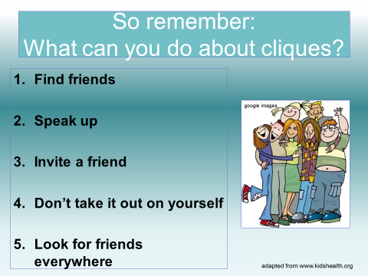
- 5 Strategies to try:
- Find friends
- Speak up
- Invite a friend
- Don’t take it out on yourself
- Look for friends everywhere

- So what do YOU think?

Your student received a Lesson Summary magnet:

If you have a moment, email _____________________________ with any information that might help your student for the next lesson on ________________________. THANK YOU!!

