What’s Happening Today?
Let’s Talk About Cliques

- What is a clique? What’s the difference between a clique and a group of friends?

- There’s usually a “leader” of the clique. Kids can act differently than before they were part of a clique.

- Why do kids join cliques?

- How does it feel to be outside of the clique?

- People in a clique might feel badly about how they treat others but not know what to do about it.

- There are people who can help you

- You can help yourself with these strategies:
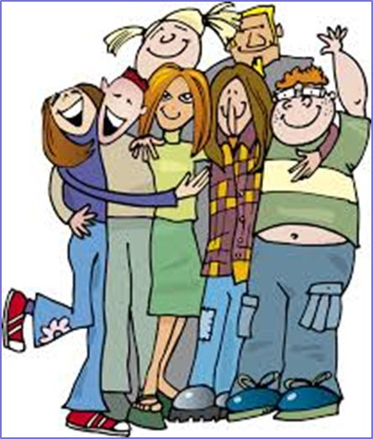
- Find friends
- Speak up
- Invite a friend
- Don’t take it out on yourself
- Look for friends everywhere

- So what do YOU think?

- Get your magnet!

