What’s Happening Today?
Let’s Talk About Being a Bully

- What is a bully?

- What does bullying look like?

- Are you a bully and don’t know it?

- Quick bully quiz

- 3 Steps to take to stop being a bully

- Close your eyes and think back to when someone hurt you. How did it feel?
- Think about your behavior towards someone else. (what did you do, who did it hurt, helpful or hurtful, what you can do differently next time)
- Ask an adult for help

- So what do YOU think?

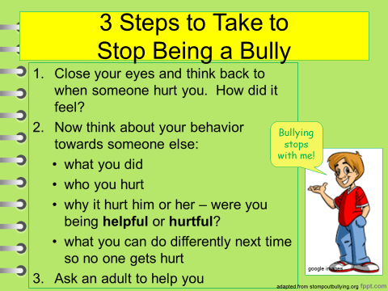
- Get your magnet!

